|  |
| --- |
| projeCT PROPOSAL  Key Companion |
| Vittorio Truglio - 219179512 SIT120 Introduction to Responsive Web Apps  Assessment 1: Project Plan, Analysis and Design |

**Project Abstract**

**Product Summary**

Key Companion is a website aimed at social enrichment through the ability to meet and communicate with people from across the world. A play on ‘Pen Pal’, Key Companion is a twist on the decades old practice, allowing users to garner new experiences and build new companionships all from behind a keyboard.

By providing information on their own interests and hobbies, users can curate an experience unique to them that shares common ground with likeminded and interested individuals. Furthermore, Key Companion is aimed to be fully functional on mobile as well as desktop devices, ensuring a user is given every opportunity to take the most from this service.

**Asset List**

An example of the main assets Key Companion is going to utilise are provided as follows:

|  |  |
| --- | --- |
| Asset | Details |
| index.html | A HTML file displaying as the ‘home page’ to Key Companion. |
| style.css | A CSS file, acting as the stylesheet for design features of the website. |
| main.js | A JavaScript file, acting as the main file to utilise and implement relevant js features. |
| navbar.css | A CSS file, providing links to differing sections of the website for ease of access for the user. |
| chat.css | A CSS file, it allows users to chat with other users, further utilising separate css file components to function. |

**Project Purpose**

**Target Audience**

**Young People**

For the demographic of young people, Key Companion aims to provide users the means of gaining new and rewarding experiences through friendships that would otherwise be unavailable to them. As such, this service allows an aged group that would already have developed online communication as well as base technological skills the means to engage with other such individuals who are not bound by local restriction.

**Language Students**

Language students who are looking to enrich their respective language skills can gain real value through a more intimate learning experience. By actually having the opportunity to utilise their developing vocabulary with native speakers, Key Companion offers a way to form new friendships and benefit from them academically.

**Demonstrating Creativity**

**Unique Approach to Online Communication**

Acting as a means of communication between users, Key Companion is not limited to a local community but rather, seeks to bridge gaps that extend by seas and borders. As such, it offers a unique experience between differing cultures and peoples.

**Means of Alleviating Loneliness and Stress**

Following the impact of a recent global pandemic, loneliness has had a dramatic effect on all peoples. Key Companion offers a way of combating this rise in negative emotion with a less stressful approach from behind a computer screen.

**Designed with Being Responsive and Simple in Mind**

With a simple and sleek design, Key Companion is designed as being easy to navigate and complication free in use. Further to this, all pages fully implement responsive web design to allow for access across a myriad of devices both desktop and mobile.

**Intended Behaviour**

**Pages Explanation**

An explanation of three main pages of Key Companion as well as used components is provided as follows:

|  |  |
| --- | --- |
| Page | Explanation |
| index.html | Acting as the home page for Key Companion, this page will be critical in acting as a hub for users to navigate from, as well as access information unique to them such as their profile name and picture and local time and date. This extends to relevant components such as the navbar.css file, which will render links to other pages from the index page. |
| contacts.html | Illustrates contacts that the user has communicated with before by their name and provided profile image. An example of a relevant component here would be react conditional rendering, being an element of the page that showcases to the user who is currently online. |
| chat.html | This page depicts both the chat history and chat box for the user, allowing for discussion in real time with their relevant contacts. Here, the component chat.css is utilised alongside a myriad of individual .css and .js files to allow for a functioning chatbox and readable text history for the user to have access to. |

**User Stories**

|  |  |  |
| --- | --- | --- |
| Statement | Acceptance Criteria | Priority |
| As a user I want to be able to send and receive messages through text. | 1. User can type a message through the provided chatbox and send the message to a friended user. 2. User can receive a message sent by a friended user. | Priority: 1/High |
| As a user I want to be able to access Key Companion on my mobile device when I’m away from home. | 1. Website is designed within code to be responsive, providing design features that operate on differing device displays. 2. All interactable features still operate correctly with dimension changes on displays. 3. User can access and navigate Key Companion without fault. | Priority: 1/High |
| As a user I want the current and local weather to be shown on my hub page. | 1. User grants inquiry for location from page. 2. Page retrieves provided weather data from location information of current device. 3. User can access weather data as illustrated on hub page. | Priority: 3/Low |

**UX/UI Design**

As mentioned prior in the project proposal document, by design, Key Companion is aimed to be sleek and simple.

From a standpoint of visuals, Key Companion’s web pages are to focus on differing shades of whites and grays to differentiate navigation buttons, menus, and the general appearance of the page. With certain coloured highlights present, however, this implementation of colour will give pages some more character beyond this neutral backdrop.

Regarding design from a practical standpoint, Key Companion is built with both structure and being responsive in mind, allowing it to be accessible from a mobile device where required.

Example of Desktop view:

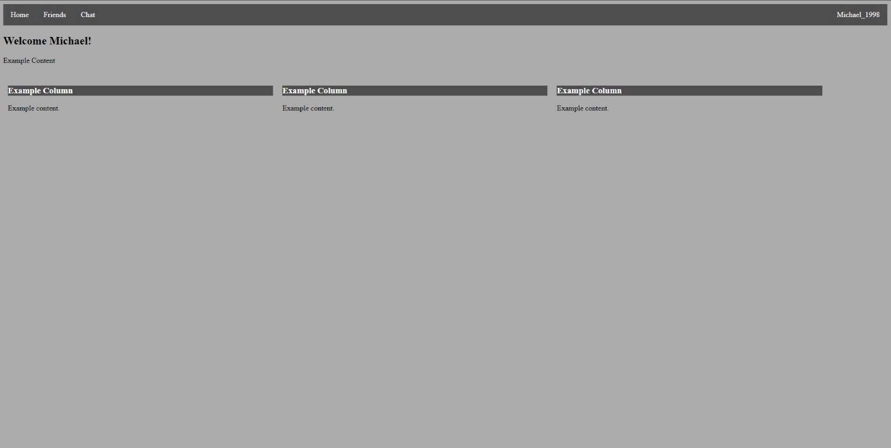

Example of Mobile view:

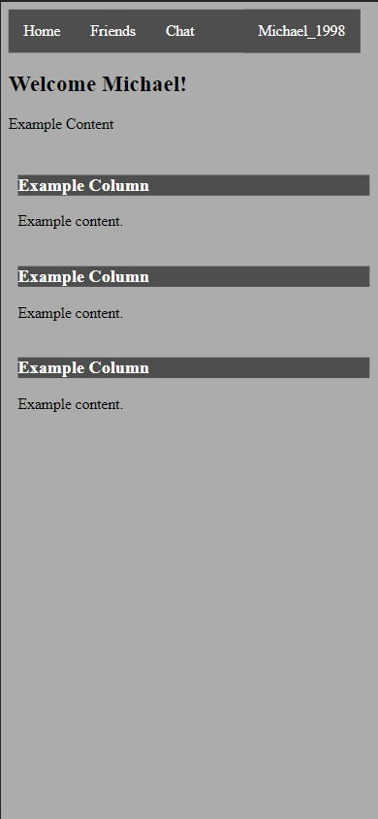

**System Summary**

Through an analysis of all the previously awarded information and illustrated elements, by fully utilising the programming languages of HTML, CSS, and JavaScript, the feasibility of this website, while ambitious, is possible to be achieved to a good standard. With good coding structure at the forefront of this endeavor, the task can be simplified, and possible problems can be addressed to an easier degree. The relationship between differing components and stages in how the system runs will rely on the aforementioned file types, as well my own skillset.

For example, the following diagram illustrates the user journey through the log in process of the website as well as how differing components relate to one another:

